UNITED STATES

SECURITIES AND EXCHANGE COMMISSION
Washington, D.C. 20549

SCHEDULE 13G

(Rule 13d-102)

Under the Securities Exchange Act of 1934

Cango Inc.

(Name of Issuer)

Class A Ordinary Shares, par value US$0.0001 per share

(Title of Class of Securities)

137586103^{i}
(CUSIP Number)

December 31, 2018

(Date of Event Which Requires Filing of this Statement)

Check the appropriate box to designate the rule pursuant to which this Schedule is filed:

- Rule 13d-1(b)

- Rule 13d-1(c) ☒ Rule 13d-1(d)

*The remainder of this cover page shall be filled out for a reporting person's initial filing on this form with respect to the subject class of securities, and for any subsequent amendment containing information which would alter the disclosures provided in a prior cover page.

The information required in the remainder of this cover page shall not be deemed to be "filed" for the purpose of Section 18 of the Securities Exchange Act of 1934 ("Act") or otherwise subject to the liabilities of that section of the Act but shall be subject to all other provisions of the Act (however, see the Notes).

______________________________
^{i}This CUSIP number applies to the Issuer’s American Depositary Shares, each representing two Class A ordinary shares.

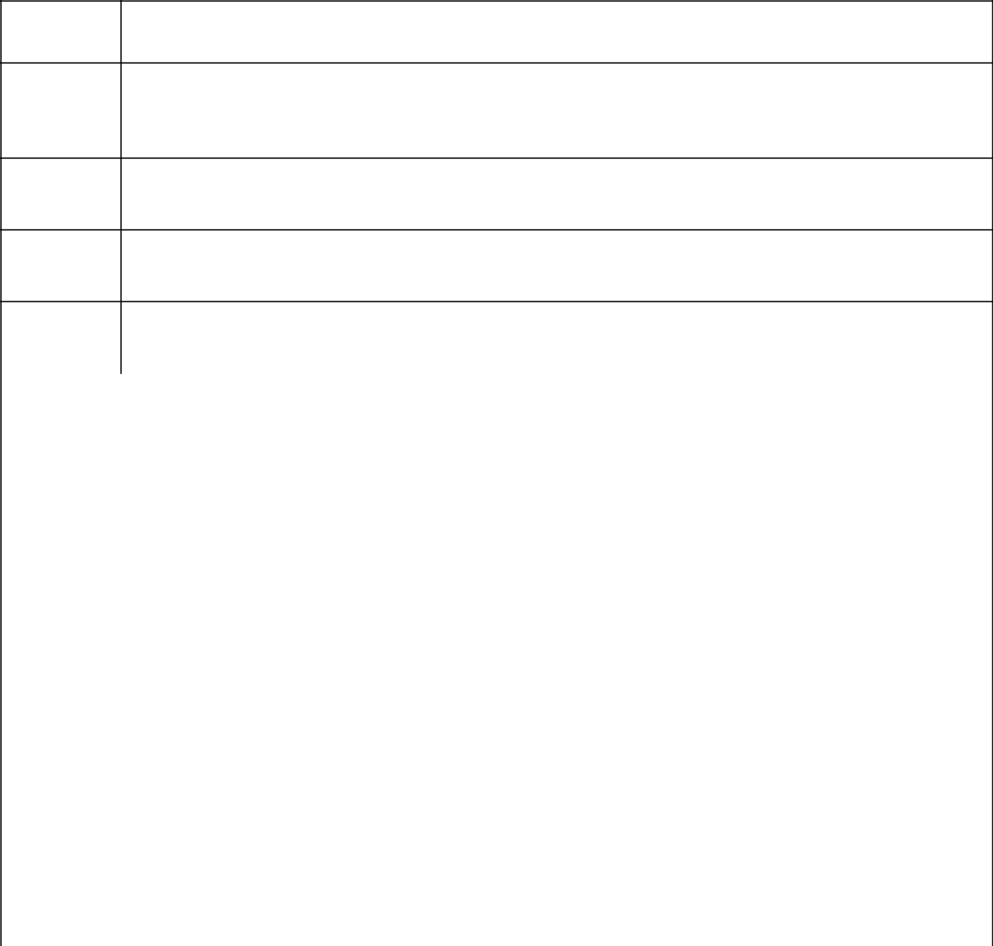
CUSIP NO.

137586103

NAMES OF REPORTING PERSONS

1

Primavera Capital Management Ltd

CHECK THE APPROPRIATE BOX IF A MEMBER OF A GROUP (SEE INSTRUCTIONS)
- (a)☐

(b)☐

SEC USE ONLY
3

CITIZENSHIP OR PLACE OF ORGANIZATION
- Cayman Islands

 |  | 5 | SOLE VOTING POWER
 |  | 5 | 12,487,876 Class A Ordinary Shares^{ii}
 |  | 6 | SHARED VOTING POWER
NUMBER OF SHARES |  | 6 | 0
BENEFICIALLY |  |  | 0
OWNED BY EACH
 |  |  | SOLE DISPOSITIVE POWER
REPORTING PERSON |  | 7 | SOLE DISPOSITIVE POWER
WITH: |  | 7 | 12,487,876 Class A Ordinary Shares^{iii}
 |  | 8 | SHARED DISPOSITIVE POWER
 |  | 8 | 0
9 | AGGREGATE AMOUNT BENEFICIALLY OWNED BY EACH REPORTING PERSON
9 | 12,487,876 Class A Ordinary Shares^{iv}
10 | CHECK IF THE AGGREGATE AMOUNT IN ROW (9) EXCLUDES CERTAIN SHARES
10 | Not Applicable
11 | PERCENT OF CLASS REPRESENTED BY AMOUNT IN ROW (9)
11 | 5.6%^{v}
12 | TYPE OF REPORTING PERSON (SEE INSTRUCTIONS)
12 | IA

______________________________
- Represents the sum of 10,308,662 (which is owned directly by Zodiac One Limited, of which Primavera Capital Fund II L.P. is the sole owner, and of which Primavera Capital Management Ltd is the investment manager) and 2,179,214 (which is owned directly by PV Peacock Limited, of which Primavera Capital Management Ltd is the sole owner).
- See footnote ii.
- See footnote ii.
- Calculation is based upon 223,484,172 Class A Ordinary Shares outstanding as of December 31, 2018.

Item 1(a) Name of issuer:

Cango Inc.

Item 1(b) Address of issuer's principal executive offices:

10A, Building 3, Youyou Century Plaza, 428 South Yanggao Road, Pudong New Area, Shanghai 200127, People’s Republic of China

Item 2(a) Name of person filing:

Primavera Capital Management Ltd

Item 2(b) Address of principal business office or, if none, residence:

28 Hennessy Road, 28th Floor, Hong Kong

Item 2(c) Citizenship:

Cayman Islands

Item 2(d) Title of class of securities:

Class A Ordinary Shares, par value US$0.0001 per share

Item 2(e) CUSIP No.:

137586103

Item 3. If this statement is filed pursuant to §§ 240.13d-1(b) or

240.13d-2(b) or (c), check whether the person filing is a:

Not applicable

Item 4. | Ownership.
 | (a) | Amount beneficially owned: | 12,487,876^{vi}
 | (b) | Percent of class: | 5.6%^{vii}
 | (c) | Number of shares as to which the person has:
 |  | (i) sole power to vote or to direct the vote: |  | 12,487,876^{viii}
 |  | (ii) shared power to vote or to direct the vote: |  | 0
 |  | (iii) sole power to dispose or to direct the disposition of: |  | 12,487,876^{ix}
 |  | (iv) shared power to dispose or to direct the disposition of: |  | 0

______________________________
- See footnote ii.
- See footnote v.
- See footnote ii.
- See footnote ii.

Item 5. Ownership of Five Percent or Less of a Class.

Not applicable.

Item 6. Ownership of More Than Five Percent on Behalf of Another Person.

Not applicable.

Item 7. Identification and Classification of the Subsidiary Which Acquired the Security Being Reported on by the Parent Holding Company or Control Person.

Please see Exhibit A

Item 8. Identification and Classification of Members of the Group.

Not applicable.

Item 9. Notice of Dissolution of Group.

Not applicable.

Item 10. Certification.

Not applicable.

SIGNATURE

After reasonable inquiry and to the best of my knowledge and belief, I certify that the information set forth in this statement is true, complete and correct.

Dated: July 2, 2019

PRIMAVERA CAPITAL MANAGEMENT LTD

By: /s/ Fred Zuliu Hu

Name: Fred Zuliu Hu

Title: Authorized Signatory

EXHIBIT A

10,308,662 Class A Ordinary Shares are owned directly by Zodiac One Limited, of which Primavera Capital Fund II L.P. is the sole owner, and of which Primavera Capital Management Ltd is the investment manager, and 2,179,214 Class A Ordinary Shares are owned directly by PV Peacock Limited, of which Primavera Capital Management Ltd is the sole owner.

